Normal PCA on coefficients

The purpose of this document is to explain the approach of the experiment 1.4. The approach tries to reduce the dimensionality of the data.

# Input data

The input data to the module is an RPy representation of a set of function data (fd) objects. These objects can be created with the “fda” – library.

The fd - object consists of a set of basis functions and a set of coefficients that represent the original function as linear combination of these basis functions.

# Approach

The approach of this experiment is to use the coefficients and perform a standard PCA on this data.

Since the coefficients for each sample is a two dimensional matric with shape (<number of basis functions>, <number of dimensions>), each coefficient set is stacked into a single vector of shape <number of basis functions> * <number of dimensions>.

The standard PCA is than applied to this set of stacked coefficient vectors. Finally the stacked coefficient vectors are transformed into the low dimensional PCA space with the eigen vectors.

With the low dimensional sample and the eigen vectors, it is easy to get (approximation) of the original stacked coefficient, which can easily be reshaped into the original coefficient matrix. Having the original basis functions, a fd – object for this sample can be calculated, which can be used to get a frame at any time on the aligned time axis.

# Experiments

The proposed algorithm is tested with 620 left stance fd objects with 5 basis functions and 57 Dimensions. All frames are represented in the Cartesian space, having 19 joints. All left stances have a length of 47 frames.

The dataset is tested with keeping 90%, 95% and 99% of the explained variance ratio during the PCA step. To verify the goodness of the low dimensional representation, both, the number of PCs and some errors are calculated.

The errors will be the maximum difference in one frame per dimension, giving 57 errors at all. Also the standard deviation (σ) and the mean (µ) of this error is expressed per dimension.

The errors are calculated for each sample and each frame, giving us 620 * 47 errors for each dimension.

# Results

## 90% explained variance ratio

Number PCs: 7

Maximum Errors per dimension (in cm):

[ 3.03248029 2.7550271 4.38847235 3.24016626 2.77471613

4.33789215 3.79023468 2.76811265 5.62924844 4.59063602

2.74868132 8.59075263 4.77948149 2.67830975 9.0283572

7.07642918 3.19776401 8.79267689 12.21637949 5.05005125

9.33277162 17.40635502 7.54219145 8.5875662 12.3682485

8.20833138 12.56948748 5.20107702 2.98768448 7.57026906

7.50245697 3.07531987 8.92051116 14.07063186 4.21067476

9.39322875 12.87293661 5.86397369 12.07108962 5.94890051

2.47752079 4.77570563 7.08277689 2.81320956 9.30930918

8.66522058 5.14397536 10.78368996 4.07958559 3.02035602

4.51127178 8.38308448 2.74300484 15.30821205 8.28072022

5.85789665 13.02946738]

Mean per Dimension (in cm)::

[ 0.55457306 0.40792585 0.7245438 0.57030612 0.40451673 0.72306916

0.58638531 0.39738129 0.78387521 0.75715062 0.40017607 1.13385528

0.8287854 0.41105202 1.28601152 0.73668972 0.47751679 1.09028849

0.80714851 0.66169948 1.16092149 1.19429325 1.08239553 1.0723193

1.88065994 1.40711185 1.53943852 0.76777064 0.45431642 1.09631677

0.9792087 0.67685592 1.27840464 1.31336506 1.01829035 1.38300888

1.8850735 1.2179839 1.98572627 0.64287293 0.39985148 0.95618178

1.11813834 0.49101603 1.41608772 1.58296741 0.77983742 1.89517396

0.6360709 0.46136743 0.89606561 0.94194557 0.49883348 1.32835238

1.37563484 0.46397495 1.74397336]

Standard deviation per dimension (in cm)::

[ 0.44686407 0.36755211 0.61531695 0.48187529 0.36305308 0.60766159

0.50748154 0.35710054 0.70260471 0.64005834 0.35828631 0.98428592

0.70392642 0.36530974 1.09460432 0.62150834 0.38782719 0.94653759

0.74173659 0.5229003 0.97489513 1.11586956 0.830306 0.88805812

1.52453829 1.14108124 1.2649175 0.64054824 0.38135329 0.93999385

0.84861394 0.52696478 1.0424365 1.03768836 0.74108313 1.1634247

1.57208657 0.92763693 1.70273979 0.52145019 0.35812311 0.77458352

0.85817684 0.39290495 1.2367769 1.34428784 0.67873551 1.6209483

0.51737762 0.40410367 0.74180697 0.76365824 0.39648661 1.13511707

1.12497716 0.42017371 1.31123207]

Some plots:

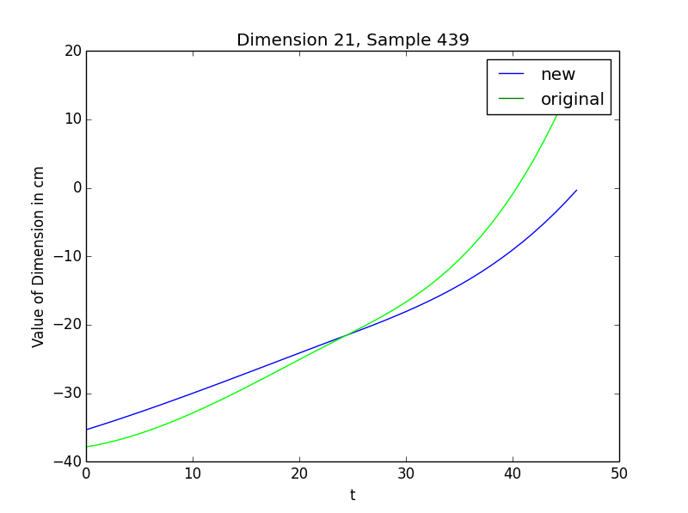

Figure 1:

The new (backprojected) and the original values of the 21 dimension in the 439th sample. In Frame 46, the total error can be seen. (17.40635502cm)

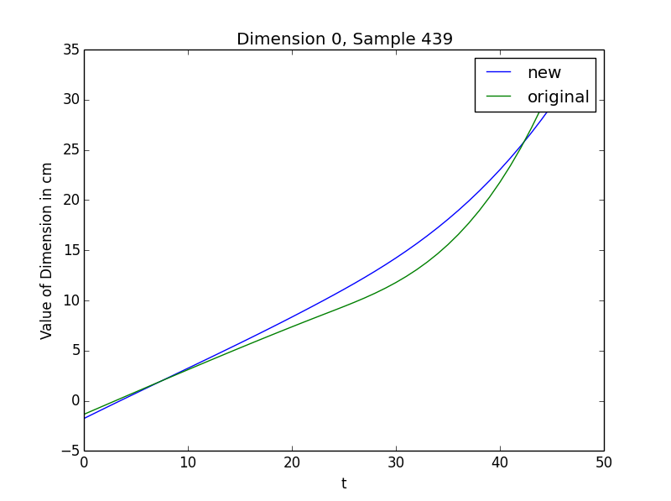

Figure 2:

The new (backprojected) and the original values of the 0th dimension in the 439th sample. (Root X position

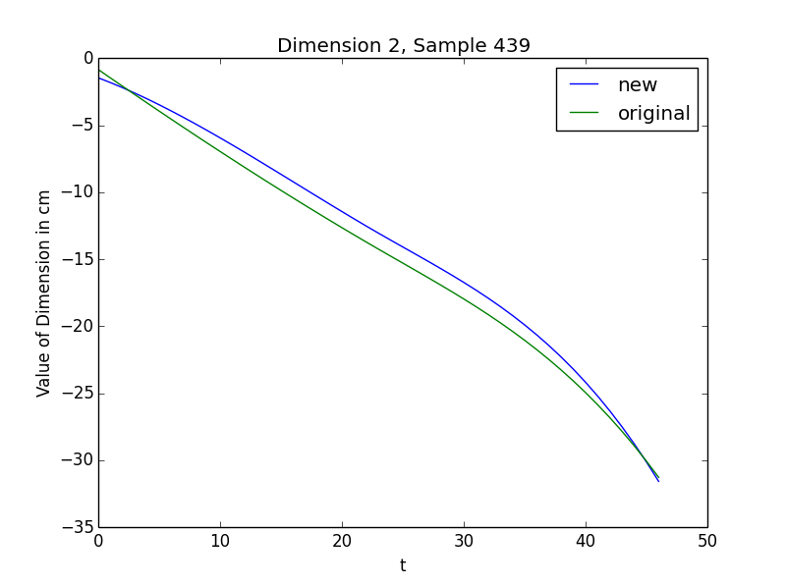

Figure 2:

The new (backprojected) and the original values of the 2th dimension in the 439th sample. (Root Z position

## 95% explained variance ratio

Number PCs: 11

Maximum Errors per dimension (in cm):

[ 3.14415286 2.84703981 3.66001152 3.33422309 2.83886134

3.75992387 3.72457794 2.87977533 3.3703928 4.63680765

2.84322995 3.83673962 4.7224578 2.73073266 4.31184951

6.59742899 2.74139807 3.24547288 10.95113787 2.70542635

5.23448799 15.9994914 4.23385721 4.52674198 12.58244897

4.72340688 7.00698742 5.63327057 3.08813935 4.54117323

7.21757241 2.94698572 4.72672413 7.38513448 4.00569857

5.22983563 8.04095386 6.06068442 9.20890897 4.7238502

2.65391506 4.1129719 6.86266245 2.87158807 5.45546308

8.9359959 4.52132561 10.21721075 3.90053107 3.050251

3.95160771 5.82804773 3.04407078 11.48426267 5.19085272

3.98058485 10.50596057]

Mean per Dimension (in cm)::

[ 0.49342717 0.26267003 0.40092904 0.51381017 0.26270204 0.42254244

0.52900493 0.2677582 0.38499976 0.69367638 0.27162224 0.51300937

0.75936549 0.28330609 0.64184707 0.66342841 0.35071558 0.51261774

0.71456623 0.46540678 0.72988611 0.86721438 0.68366456 0.98967498

1.02788788 0.91480339 1.20569363 0.71055512 0.34155186 0.5899493

0.8756188 0.49480732 0.71169791 0.95911704 0.69842964 1.08727272

1.14215327 1.00772789 1.56303679 0.55321513 0.26757529 0.55797505

1.01163683 0.36379676 0.91809595 1.3938829 0.62850541 1.4185158

0.57888512 0.31188193 0.57905925 0.73201683 0.33039167 0.71375022

1.02330049 0.35206346 0.93439016]

Standard deviation per dimension (in cm)::

[ 0.42066774 0.24553838 0.3420429 0.45161086 0.24629835 0.35253749

0.472896 0.25128966 0.33278911 0.60448382 0.25339473 0.45103446

0.66940663 0.25648435 0.54410742 0.55693208 0.28473091 0.42875189

0.6231481 0.37196564 0.58495428 0.82752288 0.54065565 0.73748001

0.8997365 0.7208742 0.98608888 0.60426515 0.30969564 0.50271996

0.7591904 0.40961008 0.58001136 0.82682447 0.5448513 0.88471715

0.94960229 0.78937969 1.29226417 0.45495458 0.24593099 0.46731977

0.79147819 0.30235973 0.78419868 1.13108638 0.58800414 1.2246205

0.4815266 0.27427733 0.48766608 0.58942193 0.28178488 0.68846444

0.80227844 0.33302505 0.76023532]

## 99% explained variance ratio

Number PCs: 28

Maximum Errors per dimension (in cm):

[ 1.16829793 0.95090551 1.36257886 1.4213976 0.95689437 1.49823286

1.35564511 0.97107939 1.01894813 1.31429208 0.99881575 1.65840616

1.63486363 1.08484557 1.89417996 1.26564252 1.2138157 1.91786645

1.70511653 1.36538789 2.11633948 2.61277267 1.94777635 2.32584602

3.89511532 2.42225287 2.76762402 1.68622237 1.28815433 1.78157843

1.83217535 1.64102439 2.71773528 2.3459047 1.95365153 2.45111833

5.30555519 2.86470515 3.60714495 1.50866261 1.00440346 1.87387863

2.35750606 1.35246416 2.92405245 3.46294042 2.78575451 4.08354731

1.92853568 1.13155517 1.82783428 2.38029929 1.67192404 3.99918115

3.19958775 1.85945432 4.20416277]

Mean per Dimension:

[ 0.22503276 0.1457489 0.25756698 0.22823475 0.14718838 0.29105656

0.14339008 0.1473581 0.18553759 0.17893917 0.15234583 0.18567742

0.23457066 0.16688423 0.31687247 0.19951556 0.19784911 0.24689167

0.25121155 0.2699616 0.37766135 0.38728797 0.32460128 0.36344084

0.44640535 0.41257555 0.43578799 0.19593974 0.20761018 0.28472928

0.27961045 0.3129757 0.39014573 0.39342567 0.31514398 0.4099071

0.46262228 0.42537402 0.41956685 0.27218122 0.16117616 0.30638481

0.38814743 0.22443359 0.41370815 0.55238665 0.36363794 0.51404857

0.26493759 0.16063651 0.36149153 0.28436351 0.17869931 0.42987091

0.36698491 0.23843756 0.47683753]

Standard deviation per dimension:

[ 0.17731346 0.12396676 0.20196761 0.18006967 0.12440039 0.23792519

0.1191285 0.12330696 0.15002539 0.14582904 0.12742807 0.15445536

0.1935149 0.13730721 0.24205826 0.16042218 0.15511433 0.2019552

0.20267501 0.20978036 0.29609351 0.30846606 0.2597729 0.29643904

0.36716517 0.34339397 0.36582208 0.16598392 0.17070322 0.23322416

0.22781645 0.24656526 0.31666206 0.31074949 0.27081474 0.33395349

0.38563787 0.35259315 0.3494499 0.21669226 0.13555506 0.24916459

0.32866731 0.17623781 0.34122533 0.46786693 0.32951878 0.43456636

0.20746559 0.13367244 0.27880401 0.24686654 0.14648404 0.37179484

0.30255324 0.20914767 0.40629271]